The Great Ocean Road Memorial Arch Survey

Please email your saved reply to the Great Ocean Road Coast Committee at info@gorcc.com.au after completing page 13 of this document.

The Memorial Arch Precinct Planning process commenced to address critical visitor safety and amenity issues on the much-loved site. Between 9.30am and 11.00 on any given day, the carpark is overflowing with tourists, with many spilling onto the Great Ocean Road to capture a “selfie” in front of the Great Ocean Road sign, and creating numerous safety issues. For 18 months, the Great Ocean Road Coast Committee, Great Ocean Road Tourism, Surf Coast Shire, DELWP, VicRoads, Regional Development Victoria and Parks Victoria have been working with a Community Reference Group to develop a plan for the future of the site.

Through extensive community consultation and in discussion with the tourism industry and bus operators, we found:
- There is support for creating alternative photo opportunities in coastal towns to relieve pressure on the Memorial Arch site and direct tourists to spend money in townships
- The heritage of the site is paramount
- There appears to be limited support for building public toilets on the already over-stretched site.

An issues and opportunities paper was released in January 2016 and outlined several significant issues associated with the current use of the Memorial Arch precinct, including:
- Overcrowding during peak visitation times.
- Safety concerns associated with undefined parking areas
- Unsafe pedestrian practices including standing on road to take photos.
- Toileting in the nearby dunes and residential areas
- Littering
- Inappropriate beach access and damage to native ecosystems.

Here are some of the options identified to help direct the master plan. Please read the full Options Paper for more context at www.gorcc.com.au.

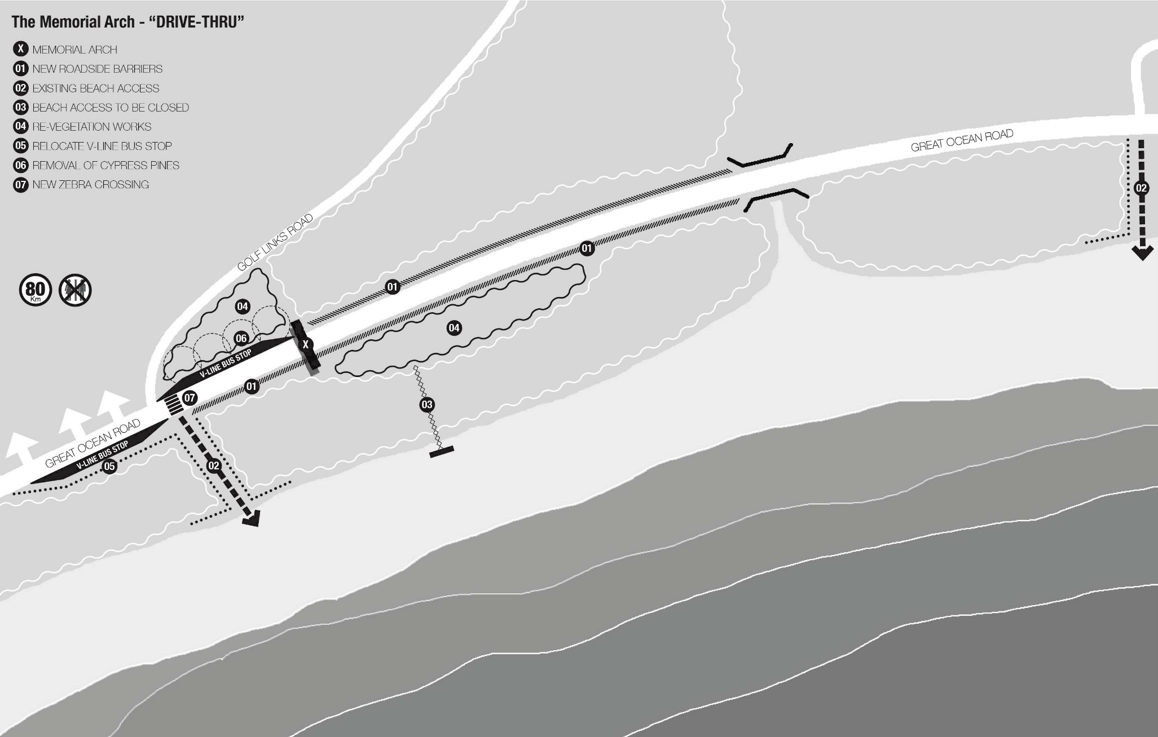

‘Drive Thru’
Overview and Design Intent
The ‘Drive Thru’ scenario is based upon the premise that the existing capacity of the site to support current, or future requirements and impacts of parking and visitor access to the Memorial Arch is not feasible or desirable. The proposition is to close the existing access, re-vegetate the roadside and return the Arch to a journey marker along the Great Ocean Road - an iconic gateway that is passed through, but not a destination to stop and experience up close. Speciﬁc elements include:
- The addition of roadside barriers, located as close to the road carriageway as possible would restrict all vehicles from stopping on the road shoulder. There may be opportunities to provide roadside barrier treatments that are integrated with the theme and character of the site, rather than generic treatments.
- The existing parking and pedestrian plaza area, beach access and all associated infrastructure would be removed and the area re-vegetated, rehabilitated and protected. The existing historical and interpretive signs and monuments near the Arch, including the Diggers Memorial statue and Great Ocean Road bronze plaque would be re-located oﬀ-site.
Assessment criteria
- The existing local beach access adjacent Golf Links Road would be retained and dune area protected (fenced). Additional deﬁnition and traﬃc control measures will be provided to create a safer pedestrian crossing at this point.
- The existing V-line bus stop to the west of the Arch would be moved slightly west (approx. 25m) to resolve the conﬂict with existing beach access and to deter use of the stop for visitation of the Arch.
- Under this (and all) scenarios the existing Cypress Trees would be removed and the area re-vegetated.
- Under this (and all) scenarios there are no toilet facilities included. A review of broader context and prevailing feedback from consultation undertaken has been that the site does not have the environmental capacity to support toilets, and that existing provision close to the site can be better utilised and promoted.

Broader Context
The ‘Drive Thru’ scenario in predicated on providing certain experiences, information and amenities away from the Memorial Arch itself, therefore is strongly linked to the adjoining and broader context of the Great Ocean Road.
The photo opportunity that currently exists at the Memorial is an important part of the experience, and according to tour operators, a key priority at the Arch for their customers. It is critical therefore that a creative, alternative option is provided. Options to be explored include:
- A sign, poster or purpose built Memorial Arch representation for photo opportunity at another location which is an existing and convenient destination / stopping point.
- A digital technology service that would enable self-portrait images to be embedded within a background image of the Arch.
The ‘drive thru’ option addresses the assessment criteria as follows:
Access and Mobility
Vehicular and pedestrian access to the Arch have been removed - which is a limitation, however safety and accessibility conflicts which currently exist have been resolved accordingly. Access to the beach is reduced, however maintained and controlled for local access.
Facilities and Amenity
The removal of access will take away the need (and opportunity) for facilities and amenities at the site itself. With the removal of direct access to the arch, no consideration of toilet facilities have been made.
Cultural Heritage
The removal of historical monuments including the Diggers Memorial statue and bronze plaque directly associated with the Arch is a limitation, however well-considered re-location and re- interpretation may offset this. Protection of the Memorial Arch and its surrounds from over- development and impact as a result of excessive site use is a positive in relation to cultural heritage.
Ecology and Environment
The opportunity to protect existing dune systems and re-vegetate as a result of removing direct access is maximised under this scenario. The risk of future damage or impact by climate change and the dynamic nature of the dune system is reduced.
Management and Broader Context
This option reduces the requirements, issues and overheads for on-going management.
Financial and Commercial
This option reduces the scope for any commercial venture at the Arch, however those opportunities could be taken up off-site through re-located elements and experiences.
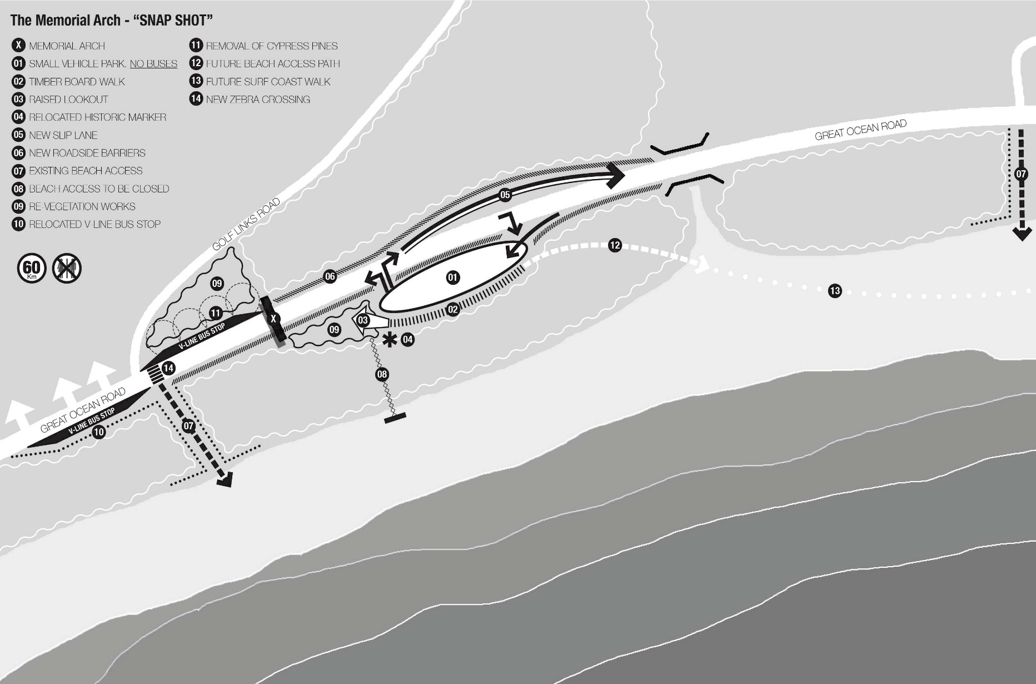

‘Snap Shot’

Overview and Design Intent

‘Snap Shot’ seeks to manage and control existing use of the site, whilst mitigating existing conﬂicts and risks. The key change from the existing arrangement is the removal of parking for large tourist buses and large vehicles from the Precinct, which has considered the traﬃc survey evidence that shows that the vast majority of site users are self-drive tourists in smaller vehicles, and the management of bus parking is problematic. Under this arrangement the existing parking space is retained in the current location but allows only small vehicles. The footprint of the existing parking area is not increased, and depending on the number and layout of spaces provided (the subject of future detailed design) there is an opportunity to reduce the existing footprint. Right and left hand turns into the car park are maintained, with the addition of a ‘slip lane’ eastbound for overtaking propping vehicles. A feature of the ‘Snap Shot’ scenario is far more deﬁned and controlled access from the parking area via a boardwalk and raised viewing lookout designed for photo opportunities with the Arch as a backdrop. The existing pedestrian plaza area close to the Arch is removed, protected and re-vegetated.

Speciﬁc elements include:
- The addition of roadside barriers, located as close to the road carriageway as possible would restrict all vehicles from stopping on the road shoulder.
- The existing Diggers Memorial statue and Great Ocean Road bronze plaque is retained but re-located in a position integrated with the boardwalk and lookout. Other existing historical and interpretive signs near the Arch would be removed in their current form and re-interpreted as part of a combined narrative and integrated within the structure rather than stand alone.
- The existing beach access path from the carpark would be closed and re-vegetated, with the local beach access adjacent to Golf Links Road retained and dune area protected (fenced). Additional deﬁnition and traﬃc control measures will be provided to create a safer pedestrian crossing at this point.
- The existing V-line bus stop to the west of the Arch would be moved slightly west (approx. 25m) to resolve the conﬂict with existing beach access and to deter use of the stop for visitation of the Arch.
- Under this (and all) scenarios the existing Cypress Trees are to be removed and the area re-vegetated.
- Under this (and all) scenarios there are no toilet facilities included.
- The speed limit is reduced to 60km/hr under this scenario.

Broader Context

The ‘Snap Shot’ scenario does remove some current experiences away from the Memorial Arch itself - particularly for tourist buses, therefore must consider adjoining and broader context of the Great Ocean Road.

As with the ‘Drive Thru’ option, the photo opportunity that currently exists for large tour bus patrons will be removed and a creative, alternative option provided. Options to be explored include:
- A sign, poster or purpose built Memorial Arch representation for photo opportunity at another location which is an existing and convenient destination / stopping point.
- A digital technology service that would enable self portrait images to be embedded within a background image of the Arch.

While historical and interpretive signs and monuments including the Diggers Memorial statue and the Great Ocean Road bronze plaque would be retained at the Arch, it would be important to provide options for information, history and signiﬁcance of the Arch to those tourists who may no longer access the site directly.

Assessment criteria

The ‘Snap Shot’ option addresses the assessment criteria as follows:

Access and Mobility

Vehicular and pedestrian access to the Arch have been reduced and controlled to respond to the safety and accessibility conflicts which currently exist. Access to the beach is reduced, however maintained and controlled for local access. More defined and well-designed boardwalk and viewing areas have the opportunity to create safer and improved all abilities access.

Facilities and Amenity

The reduced access (no large buses) has led to toilet facilities not being deemed appropriate. There are opportunities for improvements to amenities at the site such as bins, signage, barriers, and viewing areas.

Cultural Heritage

The Diggers Memorial statue and bronze plaque is retained within this scenario, and the opportunity for a more integrated location exists. The aggregation and re-interpretation of other historical and informative signage into a more single narrative is an opportunity to consolidate the unique symbolism and visitor experience of the Arch.

Ecology and Environment

The overall footprint of the parking area may not be reduced, limiting the opportunity to undertake significant re- vegetation and dune protection measures. The inclusion however of barriers, separated walking and viewing areas and reduced bach access all intend to improve the protection and quality of the environment.

Management and Broader Context

This option, with reduced access and the removal of large bus access has the opportunity to simplify and reduce the requirements, issues and overheads for on-going management.

Financial and Commercial

This option has some, if limited scope for any commercial venture at the Arch, however those opportunities could be taken up off-site through re-located visitor amenities and experiences.

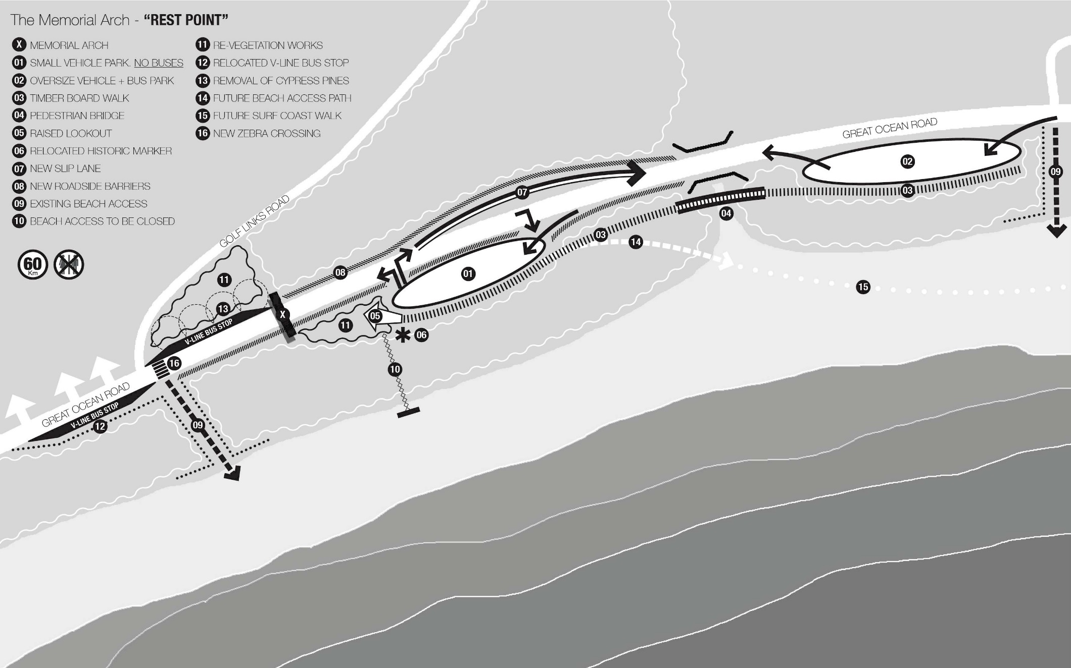

Rest Point

Overview and Design Intent

The ‘Rest Point’ scenario is an extension of the ‘Snap Shot’ arrangement but with the addition of bus parking further to the east of the current car park. This is an area currently disturbed and identiﬁed under existing GORCC Management plans for weed eradication. There is also an existing roadside lay over in the vicinity. The two parking areas are linked via a boardwalk and bridge, with a similar raised viewing lookout provided to capture views and photo opportunities of the Arch. The ‘Rest Point’ scenario in predicated on maintaining the current experiences and amenities at the Memorial Arch across a larger area to reduce conﬂicts and congestion.

In developing the ‘Rest Point’ proposition, the utilisation of the existing V-Line bus stop for tourist bus parking rather than creating a park to the east was considered, however it was felt that this location was less suitable. It is located on the departure rather than arrival side of the Arch for the majority of users, would create conﬂicts with public buses, may encourage visitors to access the Arch along the road or shoulder, and would not provide separation from tourism and local uses.

Assessment criteria

The ‘Rest Point’ proposition considers the precinct more broadly, and looks ahead towards the potential of future inter-connected walks with a series of nodes and destinations - including the Memorial Arch. It is envisaged that this scenario may be a longer term consideration, with the ability to be developed in stages.

Speciﬁc elements include:
- The addition of roadside barriers as per other scenarios.
- The existing Diggers Memorial statue and Great Ocean Road bronze plaque is retained but re-located in a position integrated with the boardwalk and lookout. Other existing historical and interpretive signs near the Arch would be removed in their current form and re-interpreted as part of a combined narrative and integrated within the structure rather than stand alone.
- The existing beach access path from the carpark will be closed and re-vegetated, with the local beach access
- Adjacent to Golf Links Road retained and dune area protected (fenced). Additional deﬁnition and traﬃc control measures will be provided to create a safer pedestrian crossing at this point.

- The existing V-line bus stop to the west of the Arch will be moved slightly west (approx. 25m) to resolve the conﬂict with existing beach access and to deter use of the stop for visitation of the Arch.
- Under this (and all) scenarios the existing Cypress Trees are to be removed and the area re-vegetated.
- Under this (and all) scenarios there are no toilet facilities included.
- The speed limit is reduced to 60km/hr under this scenario.

Broader Context

A key aspect in relation to the broader context is the consideration of future planned walks including a potential long term extension of the Surf Coast walk to Cumberland River. This provides the opportunity to see the Great Ocean Road as not only a driving route, but as a walking route with a new range of experiences, discovery and lower impact tourism.

Historical and interpretive signs and monuments including the Diggers Memorial statue and Great Ocean Road bronze plaque would be retained and re-conﬁgured at the Arch, as per the ‘Snap Shot’ scenario.

The ‘Rest Point’ option addresses the assessment criteria as follows:

Access and mobility

Vehicular and pedestrian access to the Arch has not been reduced, but controlled and dispersed to respond to the safety and accessibility conflicts which currently exist. All vehicle types are catered for. More denied and well-designed boardwalk and viewing areas have the opportunity to create safer and improved all abilities access. Direct access to the beach for visitors may be a future addition. Local beach access is maintained and controlled.

Facilities and Amenity

Whilst current access levels and anticipated visitor numbers may be maintained, toilet facilities have not been deemed appropriate. The opportunities to better utilise and promote existing facilities nearby and en-route would need to be taken. There are opportunities within this scenario for improvements to general facilities and amenities at the site such as bins, signage, barriers, and viewing areas.

Cultural Heritage

The Diggers Memorial statue and bronze plaque is retained within this scenario, and the opportunity for a more integrated location exists. The aggregation and re-interpretation of other historical and informative signage into a more single narrative is an opportunity to consolidate the unique symbolism and visitor experience of the Arch.

Ecology and Environment

The overall footprint of the existing parking area may not be reduced, and further bus parking infrastructure would be provided that will limit any net gains for re-vegetation. The inclusion however of barriers, separated walking and viewing areas and reduced bach access all intend to improve the protection and quality of the environment. The provision of extensive constructed boardwalk, bridges and viewing areas may be at risk of future climate change impacts including storm surge and sea level rise.

Management and Broader context

This option does not reduce overall access and anticipated visitor numbers. The dispersion of facilities and infrastructure does expand the site area which may present more onerous requirements, issues and overheads for on-going management.

Financial and commercial

This option, with expanded and more dispersed facilities and infrastructure may present more scope for commercial ventures at the Arch.

Survey reply

Please rank these options for the Memorial Arch from most desired (1) to least (3) and send the saved completed survey to the Great Ocean Road Coast Committee at info@gorcc.com.au.

Drive Thru. Based upon the premise that the current site is unsuitable as a stopping point and should be limited to a marker along the Great Ocean Road rather than a stop.

Snap shot. The key change from the existing arrangement is the removal of parking for large tourist buses and large vehicles from the precinct.

Rest Point. Extension of the Snap Shot arrangement but with the addition of bus parking further to the east of the current car park (situated on a disturbed area, subject to weed removal). The carparks would be linked by a boardwalk

None of the above

(Most desired) 1
2
(Least desired) 3

Do you have another idea or would like to provide a comment on your preference?

